Skills Active – Workforce Planning

Guide

Nāku te rourou nāu te rourou ka ora ai te iwi
With my basket and your basket the people will thrive

Invest in skills | Invest in people

Contents

What is workforce planning? 2
Introduction 3

Step 1: Business context and environment 4
Step 2: Current workforce profile 5
Step 3: Future workforce requirements 6
Step 4: Gap Analysis, workforce plan and training needs 7
Step 5: Review and Evaluation 10

What is workforce planning?

Good workforce planning habits will ensure that you have the right people with the right skills at the right time. Planning ahead will save you time, productivity and money.

Reviewing the workforce development needs of an organisation considers the skills, knowledge and behaviours that your people will need and how you can support them to develop these effectively.
Workforce planning cycle
The key parts of workforce planning are:
- understanding your current and future business goals,
- identifying the capacity and capability of your current workforce to meet these;
- forecasting the capacity and capability of the workforce you think you will need,
- identifying any gaps and using this information to guide the development your workforce strategy; and
- Evaluating and reviewing how you are progressing with your adopted strategy.

Resource: Online templates
Resource: Online template and IDA/LSA promt

Introduction
Looking at the skills of your volunteers, staff, management and leadership is an important part of setting up your business to succeed. Many feel they do not have the people, time or tools to undertake workforce planning.

This guide is designed to help you undertake workforce planning activities. It doesn’t need to be hard, and our Skills Active advisors are available to support you to meet your workforce planning needs. Each step in the workforce planning process is described and templates are provided to help you capture your workforce planning information.

This toolkit provides you with a variety of tools and templates that you can use and adapt to the needs of your business or organisation. Once you have completed these templates, you will have a great set of information and resources that you can use and update at any time.

Skills Active has developed a set of basic and comprehensive templates to accompany this guide. These templates are intended to help a variety of local, regional and national organisations navigate the workforce planning process and are referenced throughout this guide. Depending on the level of information available to you, and your organisation’s HR systems and processes, you may choose to use either one of these templates, or develop your own planning tools.

If you feel you don’t have information available to fill out all the sections in the templates – Don’t Fret! Complete what you can. Use these tools to facilitate conversations across your team and organisation. It’s important to start planning with the information you have. If you think it will be valuable to you, you can always gather more information later on.

The five steps to effective workforce planning:

Step 1: Business context and environment

Workforce planning needs to be directly linked to your business goals. It’s important to have a good understanding of the current environment that your business is operating in, and your future business goals. Your workforce needs to be equipped to do its job now and in the future. Understanding where you are going will help you plan your workforce needs, and turn your goals into reality. To begin looking at your business context and environment, ask yourself the following questions:
For more information about what is happening in your industry and how it may impact your business needs, please contact one of our Skills Active advisors.

What are our business goals?
- What are our short, medium and long-term business goals, and what is our vision?
- Who are our customers and who will our customers be in ten years’ time?

What are the internal and external factors that may have an impact on us reaching these goals?
- Where are we heading? Are we planning any significant changes, are we introducing new ways of working, are we anticipating future growth or downsizing?
- What is happening outside of our business that might affect us? Are there any industry trends or changes, economic conditions or market shifts that will impact our business?
- What is happening within our business, and how is this affecting us?
Templates available:
- Capturing our Business Context and Environment – Basic
- Capturing our Business Context and Environment – Comprehensive

What does this mean for our workforce?
- What workforce skills and capability will we need to meet our business goals?

Step 2: Current workforce profile

You know where you want to go, but what do you know about the people that will get you there? After looking at your business needs and goals it is important to review what you know about your existing workforce and what is going to need to change to help you meet your goals. After all, your staff are the ones that will get you there.

Information is power – and the more information you have about your staff the better will be able to identify strategies to get the most from your team. The types of information that are useful when looking at the current profile and needs of your workforce are:

- employee data, such as: demographics, distributions, staffing levels, pay rates, staff retention rates
- vacancy and recruitment activities, for example: vacancy lengths, recruitment rates, application numbers
- exit information (this may be sought through employee surveys, termination information, resignation letters)
- influences on staff (for example change in business direction, budgets, market pressures)
- current skills, competencies and development aspirations of your staff
- how staff are rewarded and recognised
- comparisons between your information and that of similar organisations, or with national data.

Information is gold!

Skills Active Workforce Scans provide access to national industry data.

For information on your industry at a regional and national level, please contact our Skills Active advisors.
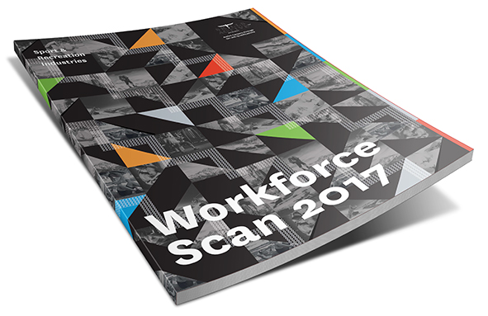
Templates available:
- Current Workforce Profile – Basic
- Current Workforce Profile – Comprehensive
- My Workforce Strengths Analysis

Step 3: Future workforce requirements

So you have identified your vision and business goals and have a profile of your current workforce. Now is the time to think about the workforce you will need to help you achieve your goals. Does your current workforce have all the skills, capability, and capacity to help you achieve your future plans, or will you need to make some changes? Ask yourself:

- What will we need? What is our ideal capacity, where are our skills shortages, and what are our workforce challenges (who and how many)?
- What is changing for us and what are our risk areas? (Refer to steps one and two.)
Templates available:
- My Future Workforce Requirements – Basic
- My Future Workforce Skill Needs – Comprehensive
- What skills will my staff need, to adapt to the environmental changes we have identified?
- What future job roles will be undertaken?
- What are the skills and competencies that we will require of all of our staff? What are our priority areas for development?
- What are the skills and competencies that we will require of our leaders, technical experts and support staff?

When thinking about workforce skills, it can be helpful to break this down into core capabilities across the organisation, functions across the different areas of the organisation, and skills required in the various roles. The diagram below outlines some questions that will help you identify your future workforce skill needs.

Workforce Skills

Step 4: Gap Analysis, workforce plan and training needs

Workforce needs gap analysis
You have now identified what your current workforce looks like, and what your future workforce will need to look like. It’s time to compare the two – what’s different? What do you need more of, or less of? Comparing what you have with what you need will help you identify any gaps that may exist in the skills, capability and capacity of your workforce. It will help you to develop strategies that will reduce the gap between your current workforce and workforce of the future. Explore:

- What are the gaps in core, functional and role-specific skills?
Templates available:
- My Workforce Gap Analysis - Basic
- My Workforce Gap Analysis - Comprehensive
- What priority would you give each gap?
- What types of things could you do to address this gap?
- Who should be responsible for addressing each gap?
- When do these gaps need to be addressed by, and what
resources do you have to address them?

Workforce plan
After you have identified the gaps, you will be equipped to develop a strategy that will help you build your future workforce. It is useful to document the specific workforce development activities that you need to do in order to grow the capability, capacity and productivity of your workforce.

When developing your workforce strategy you should think about the areas that need to be changed, managed and developed. These will fall across the following focus areas:

- Planning – How will you plan for, understand and approach your current and future workforce requirements.
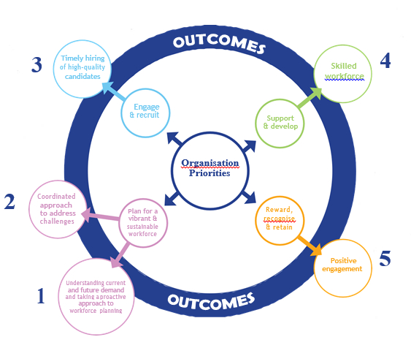
- Engagement and recruitment – How do you get the right people, and from where?
- Support and development – What are the different types of training and education opportunities that will meet your needs and the needs of your staff?
- Reward, recognition and retention – How will you build a positive culture and workplace and keep talented staff working for you?
- Leadership and communication – How will you foster leadership in your team / organisation?

For further information about these focus areas see: Workforce Planning Framework

Templates available:
- Workforce Development Plan
Skills Active has been working on a strategic workforce plan template which is suitable for workforce planning accross a number of organisations, buisnesses and sectors.

If you would like more information about this tool please contact one of the Skills Acitve team.

Determining your learning and development needs
You will have identified a number of different workforce needs, including building up the capability of existing and new staff to undertake the work you need them to do.

There are many ways to address any competency and skill gaps that you have identified. These may include in-house training courses, external training courses, conferences and events, national qualifications, e-learning, self-directed learning, secondment, coaching and mentoring.

Training is a great way of addressing performance and skill gaps. Engaging in a training cycle with your staff will ensure they develop where it is most beneficial for them and for the business. Training is good for business when it strongly supports business requirements. When a business has identified its skill requirements and is considering opportunities to train and upskill their staff there are a number of options to consider. These include:

Training has a number of advantages for business:

• better workforce flexibility • lower staff turnover rates • increased productivity • improved safety performance • less exposure to risk • enhanced external profile.

The benefits for the workforce include:

• increased job satisfaction • better workplace morale • increased motivation and engagement • improved skill base • potential for career advancement.

- Apprenticeship programmes
- Traineeship programmes
- Up-skilling, cross-skilling and re-skilling programmes
- Customised training programmes addressing the specific skill requirements of a business
- Recognition of prior learning processes
- On and off the job learning opportunities
- Project work
- Shadowing, coaching and mentoring
- Self-directed learning

Please talk with one of our Skills Active advisors about your training needs analysis
Templates available:
- Learning and Development Plan - Basic
- Learning and Development Plan - Comprehensive

S

Step 5: Review and evaluation

It is important to regularly check back on the strategy you put in place to make sure what you are doing is working. Review your plan when there are significant changes, or at least once a year. By reflecting on your planning process you can use what you’ve learned to improve future workforce planning processes.

Templates available:
- Review and Evaluation Sheet

